SIDDARTHA INSTITUTE OF SCIENCE AND TECHNOLOGY, PUTTUR
(AUTONOMOUS)
ENGINEERING GRAPHICS & DESIGN
COMMON FOR EEE/ME/CIVIL QUESTION BANK

UNIT – I

1. | a. | Draw an ellipse having major axis equal to 100 mm and the minor axis  equal to 70 mm. Use the concentric circle method. | [5M]
 | b. | Draw a parabola having a distance of 50 mm between the focus and  directrix. Draw a normal and tangent to the parabola at a point 35 mm from the focus. | [5M]
2. |  | Draw an epi-cycloid of rolling circle of diameter 40 mm which rolls  outside another circle (base circle) of 150 mm diameter for one revolution. Draw a tangent and normal at any point on the curve. | [10M]
3. |  | A point P is 30 mm and 50 mm respectively from two straight lines which are inclined at 75 degree to each other. Draw the rectangular  hyperbola from P within 10 mm distance from each line. | [10M]
4. |  | The vertex of a hyperbola is 60 mm from its focus. Draw the curve, if the  eccentricity is 3/2. Draw a normal and a tangent at a point on the curve, 75 mm from the directrix. | [10M]
5. | a. | Draw a hypo cycloid of a circle of 50 mm diameter, which rolls inside another circle of 180 mm diameter for one revolution counter clockwise. | [5M]
 | b. | Inscribe an ellipse in a parallelogram having sides 150 mm and 100 mm long and an included angle of 120⁰. | [5M]
6. | a.  b. | Construct a parabola with base 60 mm and length of the axis 40 mm. Draw a tangent to the curve at point 20 mm from the base. Also locate the focus and directrix to the parabola.  A ball thrown up in the air reaches maximum height of 45 meters and travels a horizontal distance of 75 metres. Trace the path of the ball,  assuming it to be parabolic. | [10M]
7. |  | Construct an ellipse, with distance of the focus from the directrix as 50  mm and eccentricity as 2/3. Also draw normal and tangent to the curve at a point 40 mm from the directrix. | [10M]
8. | a.  b. | Draw the involute of a regular hexagon of side 20 mm. Draw a tangent and normal to the curve at a distance of 100 mm from the centre of the hexagon.  - Draw the involute of a square of side 25 mm.  - Draw the involute of an equilateral triangular of side 20 mm. | [5M]  [5M]
9. | a. | Draw the involute of an equilateral triangular of side 20 mm. | [4M]
 | b. | Draw the involute of a circle of diameter 50 mm. Draw a tangent and  normal to the curve at a distance of 100 mm from the centre of the circle. | [6M]

10. | Draw an ellipse (half ellipse by concentric circle method and half by  rectangle method) having major axis equal to 100 mm and the minor axis equal to 70 mm. | [10M]
11. | Construct an ellipse when the distance between the focus and directrix is 35 mm and eccentricity is 3/4. Also draw the tangent and normal to any point on the curve. | [10M]
12. | Draw the hypocycloid of a circle of 50 mm diameter which rolls inside another circle of 100 mm diameter for one revolution. Draw tangent and normal at any point on the curve. | [10M]

UNIT – II

1. | a. | Draw the projections of the following points, keeping the distance between the projectors as 25 mm on the same reference lines.  A – 20 mm above HP and 30 mm in front of VP B – 20 mm above HP and 30 mm behind VP  C – 20 mm below HP and 30 mm behind VP  D – 20 mm below HP and 30 mm in front of VP E – On HP and 30 mm in front of VP  F – On VP and 20 mm above HP  G – Lying on both HP and VP | [10M]
2. | a. | State the quadrants in which the following points are located. A – Front view blow XY and top view above XY  B – Front and top views are above XY  C – Front view above XY and top view below XY D – Front and top views are below XY | [5M]
 | b. | Mention the relative positions of the projections of the following points. with respect to XY.  A – In the second quadrant B – In the third quadrant  C – In the first quadrant  D – In the fourth quadrant | [5M]
3. |  | A point A is 20 mm above the HP and 50 mm in front of the VP. Another point B is 40 mm below the HP and 15 mm behind the VP. The distance between the projectors of the points, measured parallel to XY is 75 mm.  Draw the projections of the points. Draw lines joining their FVs and TVs. | [10M]
4. |  | A line AB of 100 mm length is inclined at an angle of 30 degree to HP and  45 degree to VP. The point A is 15 mm above HP and 20 mm in front of VP. Draw the projections of the line. | [10M]
5. |  | Draw the projections of a straight line AB of 70 mm long, in the following positions:  (a) parallel to both HP and VP and 20 mm from each. | [10M]

- Parallel to and 20 mm above the HP and on VP.
- Parallel to and 30 mm in front of VP and on HP.
6. | Draw the projections of a straight line AB of 70 mm long, in the following positions:  - Perpendicular to HP, 30 mm in front of VP and one end 25 mm above HP.  - Perpendicular to HP, 30 mm in front of VP and one end on HP.  - Perpendicular to HP and in VP and one end on HP. | [10M]
7. | Draw the projections of a straight line AB of 70 mm long, in the following positions:  - Inclined at 30 degree to VP, in HP and one end on VP.  - Inclined at 45 degree to HP, one end 20 mm above HP and parallel to and 30 mm in front of VP.  - Inclined at 60 degree to VP, one end 20 mm in front of VP and parallel to and 25 mm above HP. | [10M]
8. | A line AB, 50mm long, has its end A away from the HP and VP than end  B. The line is inclined to the HP at 30 degree and to the VP at 45 degree. Draw the projections if end A is 35mm above the HP and 50 mm in front of the VP. | [10M]
9. | A line CD 75 The point P is 15 mm above HP and 20 mm in front of VP. Draw the projections of the line. | [10M]
10. | Draw the projections of the following points on a common reference line: A, 25 mm above the HP and 35 mm in front of the VP  B, 25 mm above the HP and 40 mm behind the VP C, 30 mm below the HP and 40 mm behind the VP  D, 30 mm below the HP and 35 mm in front of the VP E, 25 mm above the HP and in the VP.  F, 30 mm below the HP and in the VP  G, 35 mm in front of the VP and in the HP. H, 40 mm behind the VP and in the HP | [10M]

UNIT – III

1. | A square plane ABCD of side 30 mm, is parallel to HP and 20 mm away from it. Draw the projections of the plane, when (i) two of its sides are parallel to VP and (ii) and one of its side is inclined at 30 degree to VP. | [10M]
2. | An equilateral triangular plane ABC of side 40 mm, has its plane parallel to VP and 20 mm away from it. Draw the projections of the plane when one of its sides is (i) perpendicular to HP (ii) parallel to HP and (iii) inclined to HP at an angle of 45 degree. | [10M]
3. | A regular hexagonal plane of 45 mm side has a corner on HP, and its surface is inclined at 45 degree to HP. Draw the projections, when the diagonal through the corner, which is on HP makes 30 degree with VP. | [10M]
4. | A thin 30 degree – 60 degree set-square has its longest edge (diagonal) on HP and inclined at 30 degree to VP. Its surface makes an angle of 45 degree with HP. Draw the projections, choosing suitable size for the set- square. | [10M]
5. | A semi circular plane of diameter 70 mm has its straight edge on the VP and inclined at 30 degree to the HP. Draw the projection of the plane when its surface is inclined at 45 degree to VP. | [10M]
6. | A cone of diameter 50 mm and axis 60 mm has its generator in the VP and the axis is parallel to the HP. Draw its projections. | [10M]
7. | A pentagonal prism of base side 30 mm and axis 60 mm has one of its rectangular faces on the HP and the axis inclined at 60 degree to the VP.  Draw its projections. | [10M]
8. | A hexagonal pyramid of a base edge 20 mm and altitude 50 mm rests on one of its base edges on the HP such that the slant face (triangular surface) containing the resting edge is perpendicular to the HP. The resting edge is inclined at 45 degree to the VP. Draw the projections of the pyramid. | [10M]
9. | Draw the projections of a cone, base 30 mm diameter and axis 50 mm long, resting on HP on a point of its base circle with (a) the axis making an angle of 45 degree with HP and its top view making an angle of 30 degree with VP. | [10M]
10. | A square pyramid, base 40 mm side and axis 70 mm long, is freely suspended from one of the corners of its base. Draw its projections, when the axis as a vertical plane makes an angle of 45 degree with the VP. | [10M]

UNIT – IV

1. | A cube of side 40 mm, is resting on HP on one of its faces, with a vertical face inclined at 30 degree to VP. It is cut by a section plane inclined at 45 degree to HP and passing through the axis at 8 mm from the top surface. Draw the projections of the solid and also show the true shape of the section. | [10M]
2. | A pentagonal pyramid with edge of base 25 mm and axis 65 mm long, its base is resting on HP. It is cut by a section plane, inclined at 60 degree to HP and perpendicular to VP at bisect the axis. Draw the projections and obtain the true shape of the section. | [10M]
3. | A hexagonal prism of side of base 30 mm and length of axis 75 mm, is resting on its base on HP. It is cut by a section plane inclined 35 degree to HP and passing through top corner. Draw the front and sectional top views of the solid and true shape of the section. | [10M]
4. | A square pyramid of base 40 mm and axis 60 mm long, Its base lies on VP, with its axis parallel to HP. A cut sectional plane, 60 degree to VP and it pass 10 mm away from the axis. Draw the projections sectional front view. | [10M]
5. | A cone of 50 mm diameter and axis 70 mm long. Its base is on HP. It is cut by a sectional plane perpendicular to VP and inclined to HP at 45 degree from apex 32 mm. Draw the projections of FV, TV, True shape. | [10M]
6. | A square prism of side of base 40 mm and axis 80 mm long, is resting on its base on HP such that, a rectangular face of it is parallel to VP. Draw the development of the prism. | [10M]
7. | A cylinder of diameter of base 40 mm and axis 55 mm long, is resting on its base on HP. It is cut by a section plane, perpendicular to VP and inclined at 45 degree to HP. The section plane is passing through the top end of an extreme generator of the cylinder. Draw the development of the lateral surface of the cut cylinder. | [4M]
8. | A cone of base 50 mm diameter and height 65 mm rests with its base on HP. A section plane perpendicular to VP and inclined at 30 degree to HP bisects the axis of the cone. Draw the development of the lateral surface of the truncated cone. | [10M]
9. | A pentagonal pyramid, side of base 30 mm and height 52 mm, stands with its base on HP and an edge of the base is parallel to VP. It is cut by a plane perpendicular to VP, inclined at 40 degree to HP and passing through a point on the axis, 32 mm above the base. Draw the development of the lateral surface of the truncated pyramid. | [10M]

10. | A square pyramid, with side of base 30 mm and axis 50 mm long, is resting on its base on HP with an edge of the base parallel to VP. It is cut by a section plane, perpendicular to VP and inclined at 45 degree to HP.  The section plane is passing through the mid-point of the axis. Draw the development of the surface of the cut pyramid. | [10M]

UNIT – V

1. |  | Draw the isometric projection of a pentagonal prism of base side 35 mm and axis 60 mm. The prism rests on its base on the HP with an edge of the  base parallel to the VP. | [10M]
2. | a. | Draw the isometric view of a cylinder of base diameter 50 mm and axis 60 mm the axis of the cylinder is perpendicular to the  - HP  - VP | [5M]
 | b. | Draw the isometric view of a circular lamina of diameter 50 mm on all the  three principal planes using four centre methods. | [5M]
3. |  | Draw the isometric view of a cone of base diameter 50 mm and axis 60 mm. The cone has its base on  - HP  - VP | [10M]
4. | a. | Draw the isometric projection of a hexagonal prism of base side 30 mm and axis 70 mm. The prism rests on its base on the HP with an edge of the  base parallel to the VP. | [5M]
 | b. | Draw the isometric projection of the frustum of a cone of base diameter 60  mm, top diameter 30 mm and height 55 mm. | [5M]
5. |  | Draw the isometric projection of the frustum of a hexagonal pyramid of base side 40 mm, top side 25 mm and height 70 mm. The frustum rests on  the HP. | [10M]
6 |  | Draw three views of the blocks shown pictorially in figure according to first angle projection.  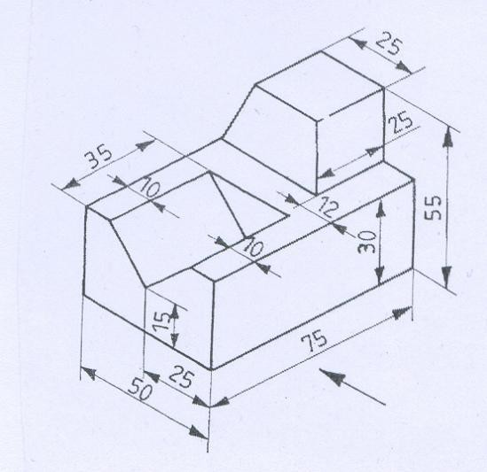 | [10M]

7. | Draw three views of the blocks shown pictorially in figure according to first angle projection.  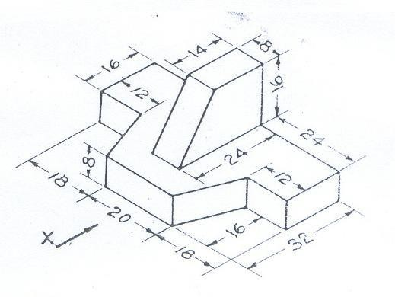 | [10M]
8. | Draw three views of the blocks shown pictorially in figure according to first angle projection.  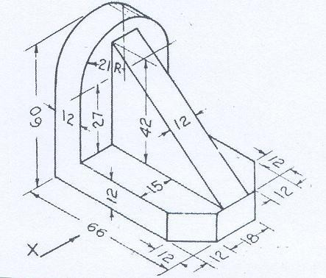 | [10M]
 |  | [10M]

9. | Draw the isometric view of the following sketch.  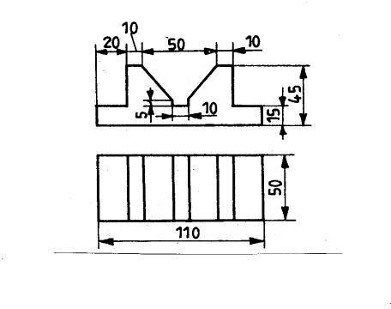
10. | Draw the isometric view of the following sketch.  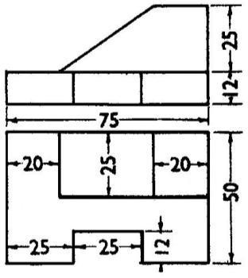 | [10M]

Prepared by: Prof. R.Suresh/ S Bala Anki Reddy

